Resume
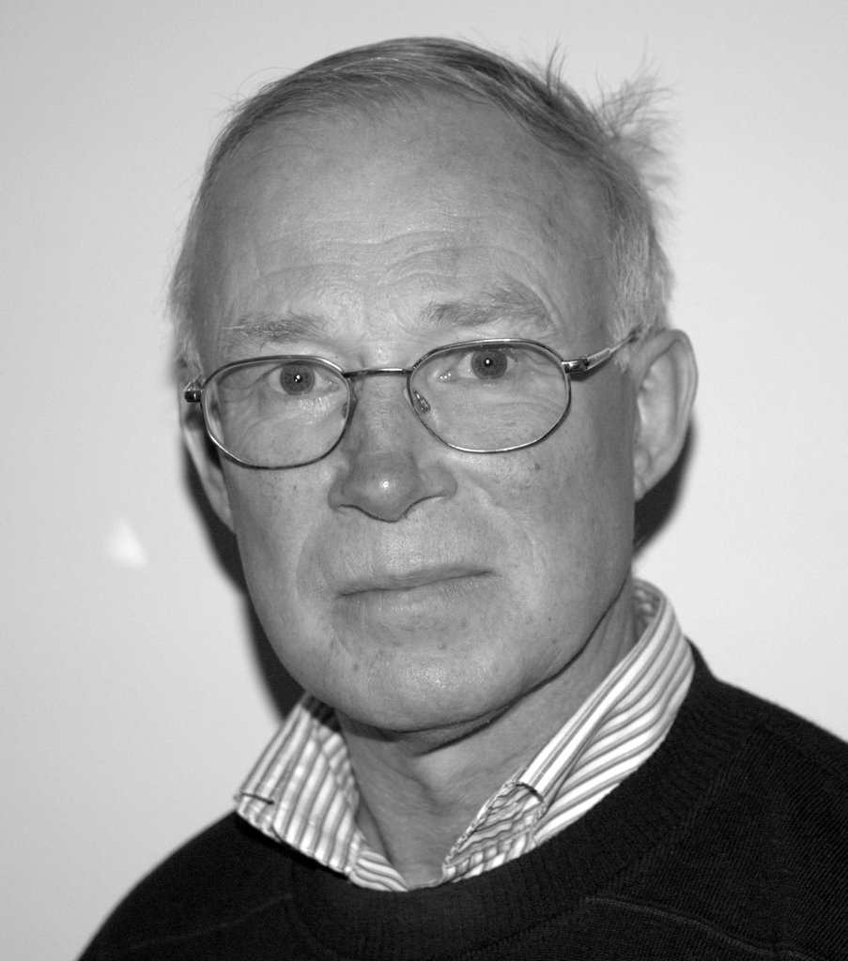
FOLMER, Henk
Title:\Dr.
Education Background:
1981 Ph.D. Economics, University of Groningen, Netherlands
1975 M.Sc. Social Science, University of Nijmegen, Netherlands
1973 B.Sc. Economics, Tilburg University, Netherlands
Working Experiences:
2010-present Professor, Economics and Management, Northwest A&F University, China
2005-present Professor of research Methods and Econometrics, Department of
Economic Geography, University of Groningen, Netherlands
1997-2004 Professor of Environmental Economics, Department of Economics, Tilburg University, Netherlands
1986-2010 Professor of Economics, Department of Sociology, Wageningen University,
Netherlands
1980-1986 Associate Professor of Economics, Department of Economics,
University of Groningen, Netherlands
1975-1980 Assistant Professor of Statistics and Research Methods, University of Groningen, Netherlands
1972-1975 Lecturer of Statistics and Research Methods, College of Traffic Management, Tilburg, Netherlands
1971-1972 Researcher, Institute of Human Resources, Tilburg University, Netherlands
1970-1971 Researcher, Institute of Regional Economics, Tilburg, Netherlands
Research Interests:
Economic methodology, and integration of the social sciences and economics. In spatial econometrics he focuses on continuous time modelling, structural equation models and modelling spatial dependence.
Professional Activities:
Founder and first President of European Association of Environmental and Resource Economics
Fellow of the Regional Science Association International
Co-editor of The International Review of Environmental and Resource Economics,
Awards:
2010 Renowned overseas scholar, Chinese Ministry of Education, China
1999 Honorary doctorate, University of Gothenburg, Sweden

